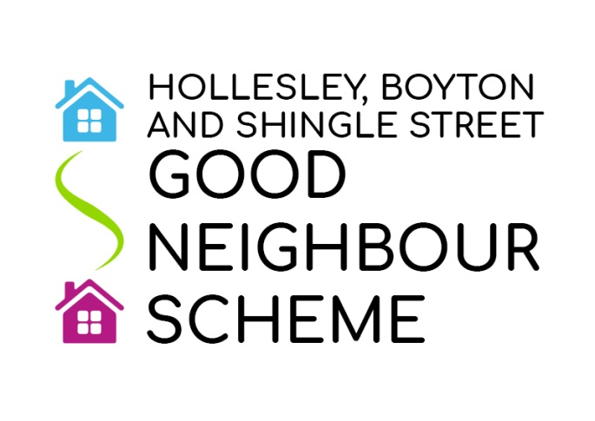

Report to Boyton Annual Parish Meeting
14 April 2021
Our Good Neighbour Scheme started three years ago, to help and befriend anyone in need in our villages. We have around 20 volunteers who were all trained and checked and could offer a variety of help, from lifts, shopping to dog walking. There were two volunteers from Boyton, but just one at the moment. If you are available and would like help or to know more, please contact us on our dedicated phone number 07707 850126 or ring me on 411232 for a chat.
During Lockdowns in the past year we have delivered many prescriptions to Boyton and also provided occasional lifts.
In normal times we also hold Meet Up Mondays at The Shepherd and Dog in Hollesley where anyone can come for free tea, coffee, biscuits, and occasionally cake! We are supported by Mc Coll’s too, and by the Coop, our District Councillor and others from time to time.
The opportunity to meet other villagers, especially for those on their own is welcomed. We have also had a special meal at the Pub, and look forward to doing this again. Some Boyton residents have received Goody Bags at times when we have been unable to meet. Sadly in the past year everything has stopped, but we hope to resume later in May, if conditions allow.
We have rarely had anyone coming from Boyton, but if a lift was available that might make all the difference! You could even do some shopping while you were in the village! We look forward to seeing you soon!
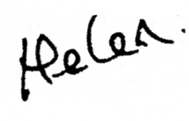

Helen Lewis

