August 2022

Welcome to my monthly newsletter

Chief Executive to retire after 17 years at the helm of East Suffolk Council
East Suffolk Council’s long-serving Chief Executive Stephen Baker, has announced his retirement . After a career in local government spanning four decades, culminating in 17 years at the helm of Suffolk
Coastal and East Suffolk , he will step down from the post at the end of this year .

As Chief Executive of the biggest district council in the country by population, Stephen has been at the forefront of local government innovation, becoming one of the country’s first ever joint Chief Executives when taking up the reins at Waveney District Council alongside his role at Suffolk Coastal.
He then oversaw more than a decade of successful, cutting-edge partnership working, culminating in the creation of East Suffolk Council, delivering the best possible services for local people. His experience and sage advice have been instrumental in making East Suffolk into an outstanding place to live, work, and visit. He can be incredibly proud of his achievements throughout his career, and he will be missed by the whole team.
To ensure a smooth transition, recruitment for a new Chief Executive is now underway, with the council looking to make an appointment in the autumn.

Bold new beach huts officially opened on Lowestoft’s seafront
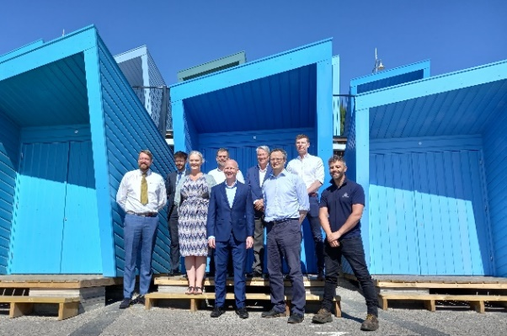 | As part of ambitious plans to enhance Lowestoft and help the town gain further recognition as a visitor destination, 72 striking new beach huts are now officially open.  The contemporary beach huts, known as Eastern Edge, have been built on the site of the former Jubilee Terrace huts on Lowestoft’s seafront.

Work began in September 2021, with the huts designed by Norwich-based architects Chaplin Farrant and manufactured by Lowestoft-based PJ Spillings, and the platform, hut installation and ancillary works undertaken by M S Oakes – also from the town.

Half of the beach huts are available to hire on a weekly basis, while 10 have been designed with accessibility in mind and are accessed directly from the promenade.

Free meals and summer holiday activities for schoolchildren
Numerous organisations have signed up to provide fun and food as part of a programme of experiences for children and young people over the coming weeks.
The Holiday Activities and Food (HAF) programme is funded by the Department for Education through an annual budget from Suffolk County Council.
The local programme is targeted at those eligible for benefits-related free school meals, and other vulnerable children, or those with additional need, that would benefit from accessing the programme.
Local authorities have discretion to use up to 15% of funding to provide free or subsidised holiday club places for children who are not in receipt of benefits-related free school meals but who the local authority believe could benefit from HAF provision.
Among offerings are Operation Camouflage, organised by the Army Welfare Service and East Suffolk Council, at Sutton Heath, near Woodbridge, and sporting activities provided by leisure partner Everyone Active, in Lowestoft.

'Efficient, clean and super green' refuse lorries hit the streets of East Suffolk
East Suffolk Council has welcomed the addition of 'efficient, clean and super green' biofuel-powered trucks to its fleet of refuse collection vehicles.

The arrival of the vehicles on the streets of East Suffolk is the latest move towards switching the entire fleet to eco-friendly fuel.

Last year, the Council approved plans to switch its diesel fleet to be fuelled by HVO (Hydrotreated Vegetable Oil) and reduce total carbon emissions by more than 30%.
An advanced renewable and sustainable fuel, HVO offers up to 90% reduction in carbon emissions compared to diesel.

The 246-vehicle fleet, mainly operated by waste management partners East Suffolk Norse, was the biggest single contributor to the Council's carbon footprint last year. A third the vehicles will initially be converted to HVO, including 60% of heavy goods refuse lorries. As your cabinet member for the environment I was really delighted to introduce this initiative, something really practical and meaningful in dealing with increasing environmental concerns .

Charity cycling event returns to East Suffolk
A popular cycling event is set to return to East Suffolk following a two-year break brought on by the pandemic.
The first Women on Wheels (WOW) event in the district since 2019 will set off from Ipswich School Sports Centre, in Rushmere St Andrew, on Sunday 4 September.

The mass participation, female-only events focus strongly on the fun, friendly and inclusive aspects of cycling – with each ride featuring routes of an achievable distance for any level of ability and experience.

Any profit from entry fees for the ride, organised by East Suffolk Council and Plomesgate Cycling Club, will be shared between two nominated charities, Lighthouse Women’s Aid and Fresh Start new beginnings.

Strategy for sustainable and inclusive future of leisure and sports facilities
This Council has renewed its commitment to improving the health and wellbeing of its residents by adopting a new strategy for leisure and sports provision.
The East Suffolk Leisure Strategy will help to ensure that the needs of the community are met by developing the provision of sport and physical activity across the district.
Key among the strategy’s will be to protect and enhance the existing supply of playing pitches and outdoor sports facilities where needed for meeting current and future demand.
The overarching strategy incorporates the Council’s Indoor and Built Sports Facilities Strategy (IBF), Playing Pitch and Outdoor Sport Strategy (PPOSS) and Open Space Report.
A total of 571 sports clubs responded consultation during the development stage of the documents, along with community groups, town and parish councils, schools, health partners and operators.
The resulting studies will prioritise areas most in need of improvement and identify ways to potentially improve existing shortfalls, while also helping the Council achieve its strategic objective of Enabling Communities by providing data that could assist with future funding bids for local improvements.

Parking review launched to evaluate changing demand and meet local need
This Council has pledged to conduct a detailed review of parking management regulations and introduce new schemes to meet changing local demand.
The review will encompass regulations such as resident parking, short term parking bays and double yellow lines, and consider a variety of factors, including shifting patterns of town centre use and growth in housing.
Cabinet members approved recommendations for the review of existing rules and the allocation of a supplementary budget for the appointment of a Highways Technician/Engineer to provide the necessary resource and capability.
The recommendation for a review follows the transferal of parking enforcement powers from Suffolk Constabulary to individual local authorities in April 2020.
The review will involve consultation with relevant town and parish councils, Business Improvement Districts, Suffolk County Council and other bodies, such as the Lowestoft Place Board and local business associations.

Misc
Cost of living community support still being developed - update soon as I have received further details

I continue to try and improve my ward – I have flagged up the footpath from Wilford roundabout to Sutton Hoo with Highways – which is now a safety concern , and wait for their thoughts – have requested the bank to be cut back so a parent and pushchair is able to walk from Melton Railway station to Sutton Hoo

Bins continue to be an issue – Shingle street bins in particular - for your guidance this is private land and the settlement committee asked for bins to be removed from the 2nd car park and I am not able to provide additional bins unless requested by the settlement group , this is not East Suffolk land

However I was able to provide a new recycling bin for our friends at Sutton Heath :
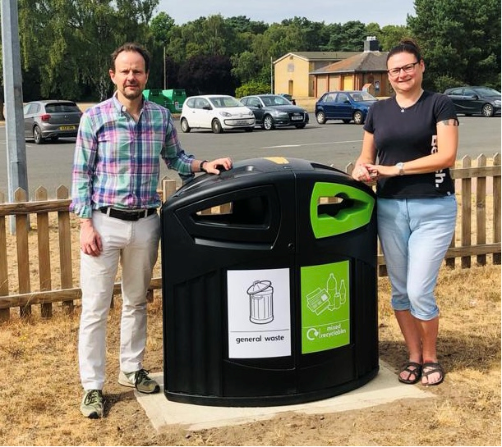

Any questions - as always here to help
And any resident struggling happy to try and help , sign post grants , East Suffolk officers etc

James Mallinder
Deben Ward
Environment Portfolio holder

