.

January 2021

Welcome to my monthly newsletter

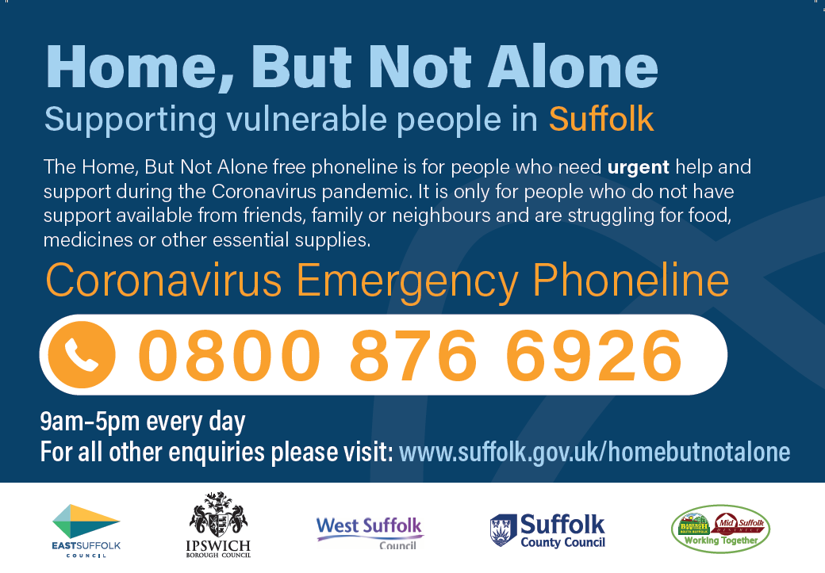

Suffolk Domestic Abuse Helpline – 0800 977 5690

Vaccinations
I understand and share concerns about ensuring our communities receive information about the vaccination roll out as quickly and effectively as possible, and it is clear that local authorities can play a role in this process. Therefore, I am pleased to confirm that the Suffolk Communications Cell, which includes representation from East Suffolk, has led on the delivery of a web resource which aims to provide clear, up to date information for stakeholders and residents.
www.suffolk.gov.uk/covidvaccinations
Stay at home and stay safe
I spoke with the media last week about the importance of staying home and saying safe. I personally think it is important that we are not seen to demonise people who would like to visit this part of the country, or even travel around it - however, we must be very clear that guidelines must be followed to keep everyone safe.
However due to the number of visitors to both Shingle Street and Bawdsey I spoke to the police last week and I believe the number of patrols have now increased .
Communities and supporting residents
The Home But Not Alone phone line continues to be active
Last week the Communities Team called all those who needed support during lockdown 2. This includes anyone who was either referred to Home But Not Alone or Suffolk Advice and Support Service, are lonely or isolated, were helped to register with the National Shielding Support Service or had other needs identified . And we continue to make sure resources are focused on those that need help the most.
The Covid-19 Hardship Fund has been topped up so if any local groups would benefit from additional funding during the third lockdown, please let me know .
As always anybody can speak to me in confidence, and if I can not help I will signpost to other organisations .
The following information might be helpful for any residents who are in need of support with shopping/medication deliveries:
The Teapot Project – reduced rates available for food delivery via discount codes on order pages: www.theteapotproject.net
Woodbridge Salvation Army 07562007125
Orford Good Neighbourhood Scheme 01394 450235
Rendlesham Good Neighbourhood Scheme 07486551004
Melton Good Neighbourhood Scheme 03333355366 meltonGNS@gmail.com
Hollesley Good Neighbourhood Scheme 07707850126
Woodbridge Emergency Response Group 01394 383599

Environmental Services
Environmental Protection
The emergence of the more contagious variant of covid will affect the activities of the Environmental Protection team. As a general rule the team will not be undertaking visits to premises for any purpose. This will have an effect on proactive inspections and reactive visits for all purposes including water sampling, nuisance monitoring visits, licence and permit inspections and many other site-visits involving entry to premises. They will be exploring ways of undertaking these activities remotely.
The team had begun to make some headway in tackling the backlog off work caused by the first lockdown which led to 15% to 20% increase in reactive work from for example, noise complaints, bonfire nuisance complaints, fly tipping etc. However, they have not reached the stage yet of turning work away, since there is traditionally a seasonal lull in reactive work at this time of the year. Whether or not the situation continues depends upon progress of the pandemic and whether we will be in a better situation by the time the weather improves in the spring.
They key is evidence to any concerns so please take photographs and when reporting. Please copy me on any communication so I can monitor the pattern across the district and follow up when necessary .
Operational update
There has been no impact on refuse collection or other Norse services , however we will continue to work with partner organisations who deliver council services on our behalf to monitor sickness too and will work with them to minimise any disruption. Leisure centres closed on Boxing Day until further notice as part of the original Tier 4 regulations
All East Suffolk Council tennis courts, outdoor gyms and sporting locations under the management of the council will have signage put up saying that they are closed.

Grants, funding and business matters
As soon as details of new schemes are made available ESC will go live and promote these new funding streams in addition to the existing grants.
Please check our website for updates.
Customer Services
Our service remains unaffected as measures are already in place with a remote call centre, maintaining staff resilience to reduce absences and alternative channels of access for customers. We are encouraging people to access our services and information online where possible.
Public access remains closed; however emergency access / support measures are in place if required.

James Mallinder
Deben Ward
Environment Portfolio holder

