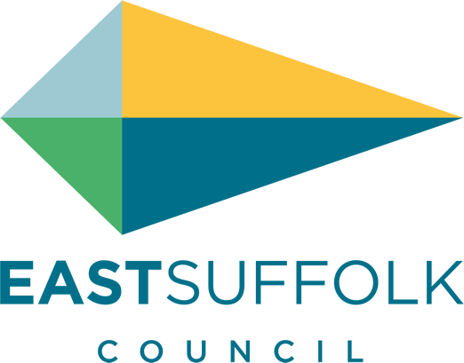

January 2022

Welcome to my monthly newsletter and a very happy new year .

2022 I hope will bring some normality to our daily lives and the positive we can draw from the last couple of years is how important our communities are to all of us .

We came together to look after those less fortunate or who needed a helping hand .

Here at East Suffolk we acted fast to support businesses with the distribution of various grants and perhaps more importunately we provided support and assistance to our residents . I have been in particular proud of our East Bags - a substantial bag of goodies esp designed for single elderly residents .

I am proud to represent the Deben ward, where in particular each village had a local group keeping an eye on residents , picking up prescriptions and food .

Or even just a friendly chat - always maintaining a covid distance

With systems in place and vaccines taken we will be in a better position in 2022. East Suffolk will continue to deliver our front line services and will make sure our residents needs are placed first in decision making. And I can certainly guarantee the Environment will also be an important focus and I will personally make sure environmental impact will continue to be a consideration . Not a binary relationship but by making sure environmental considerations are taken into account East Suffolk will play it’s part in protecting and support our wonderful environments in East Suffolk .

Support available to help businesses recover
Funding and support continues to be available for businesses in East Suffolk which have been, and continue to be, severely affected by Covid-19 restrictions.
Expert and impartial Business Growth Advisers will work with businesses to develop an action plan and complete the application.
See more information at www.eastsuffolk.gov.uk/news/support-available-to-help-businesses-recover/

Business and the environment
As part of the programme Clean Growth for Business facilitated by New Anglia LEP, we recently showcased the way in which ESC has joined forces with Greener Growth CIC to share our premises at East Suffolk House with Nature as part of the wider approach at Riduna Park, to hopefully inspire other businesses to take similar positive approaches with their spaces outdoors to accommodate nature. I was very happy to contribute to this discussion in offering opening comments https://www.youtube.com/watch?v=BIjgJ_Rx4R8&t=6s

New Trading Company to deliver key council services
As part of our commitment to seek the best possible value for money for residents, businesses and all local stakeholders, we’re creating a Local Authority Trading Company (LATCo) to play a more direct and influence role in how important services are delivered.
The LATCo will operate as an ‘arms-length’ commercial business, separate to the Council and will be responsible for crucial services such as waste and recycling collection, grounds maintenance and street cleansing.
This means that we will exercise our right not to renew the contract we hold with Norse for the provision of operational services, and therefore this contract will come to a natural end in July 2023.
Operational staff currently employed by East Suffolk Norse, will be legally entitled to transfer to the new organisation, on the same terms and conditions, through ‘protection under law’ TUPE legislation and we will be seeking as seamless a transition as possible.

Any relationship with the parish and Norse will continue as usual .

Planting trees for the Queen’s Jubilee
We are supporting ‘Treebilee’, a project launched by HRH Prince Charles to encourage the planting of trees during a year-long celebration of the Queen’s 70-year reign in 2022.
As part of this, we have purchased 200 oak trees which will be donated to every town and parish council in East Suffolk. Not only will this mark the very special occasion, but it will also help tackle climate change and contribute towards our vision to create environmentally sustainable communities.

I have reserved a tree for all my parishes and you can decide once they are available for collection if you want one .

Reducing waste for 2022
We are encouraging residents to look after the environment this new year by reducing waste and considering eco-friendly options where possible, such as ensuring wrapping paper is recyclable, only buy the food needed to avoid food waste and how to dispose of Christmas trees.

Also, there will be no changes to bin collections in 2022 so we are reminding people to leave their bins out for collection as normal.

As a result, no bin hangers will be left on the bins this year, however, people can view or down a copy of their 2022 bin collection calendar at https://www.eastsuffolk.gov.uk/waste/waste-collection-and-disposal/bin-collection/your-2022-bin-collection-calendar/

Misc

I was delighted to run the Southwold 10k in November to raise funds for Eyke village hall - Raising £560

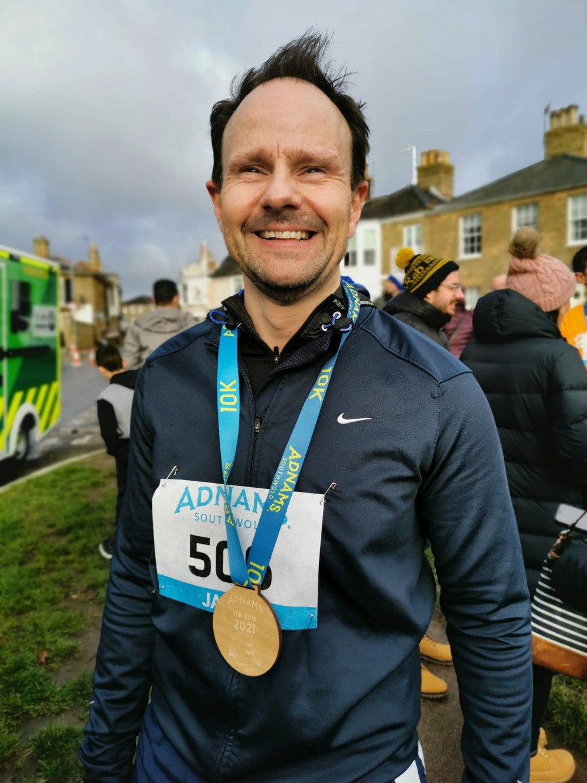

James Mallinder
Deben Ward
Environment Portfolio holder

