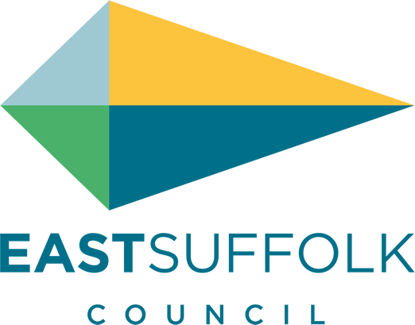

July 2021

Welcome to my monthly newsletter

Supporting Our Communities
Through our Home But Not Alone service , attention has turned to analysing the issues identified through both the pro-active and re-active calls made to Clinically Extremely Vulnerable people over the last year.

Some key areas of concern include family carers, mental ill health, financial vulnerability and isolation and loneliness. An action plan is being developed setting out how we will contribute to tackling these issues over the next 12 months, including some innovative community pilots. A new Suffolk Grant Scheme called Community Restart was been launched . This builds on the East Suffolk Bounce Back Fund funded by the East Suffolk Community Partnership Board

It offers grants of up to £2,500 to community groups and buildings to help them to ‘restart’ safely as we move through the different stages in the roadmap. Each District has been allocated £75,000 of funding and in East Suffolk this has been added to the balance remaining in our Bounce Back fund:
https://www.communityactionsuffolk.org.uk/suffolk-community-restart/

Supporting businesses
In total, since the launch of a plethora of new business grants in November 2020, ESC has made payments of more than £49m to businesses struggling due to enforced closure or severe restrictions on trading. In terms of the Additional Restrictions Grant (ARG) this means we have now allocated over 89% of ESC’s total pot, well above the national average and on course to meet the government’s 30 June deadline to have allocated all ARG monies. Since the beginning of the pandemic the Council has allocated £114m of grants.
From 1 April ESC launched its Restart Grants Fund which provides grants to supporting the reopening of non-essential retail and hospitality/ accommodation providers, leisure, personal care and gyms. For non-essential retail grants are worth up to £6k and for hospitality etc are worth up to £18k. These will be one -off payments and only for businesses who are on the ratings list. Although the payments of this grant have been delayed due the need for enhanced anti-fraud checks due to organised fraud taking place within the county, ESC has now made payments of £7.8m to 1,037 businesses.
Businesses which are not rated will receive an equivalent to the Restart Grant payment from the ARG fund. ESC will receive a top up to this fund of £1.74m dependent on the current allocation of £7.2m being fully distributed to businesses by 30 June.
The government has also recently announced the ‘Welcome Back Fund’ - £56m being made available to Councils to safely welcome back residents and visitors to high streets and coastal resorts. The funding can cover temporary measures such as signage, public realm improvements, promotional campaigns and support for events for up to 12 months or for as long as restrictions are in place. ESC has been allocated £287k and will shortly be working with Town Councils and Business Improvement Districts to develop plans for the effective implementation of this fund. Plans needs to be submitted by 30 May with the roll out expected to take place shortly after this date.
All the information relating to Covid business grants can be found on ESC’s Covid business support webpage COVID-19: business grant funding .

East Suffolk Annual Report
East Suffolk official Annual report can be found here : https://www.eastsuffolk.gov.uk/news/our-year-our-annual-report/

Misc

- I have spoken to Cllr Paul West who now has responsibility for Highway issues at the SCC and highlighted the issue of Flooding , sand, mud on our highways and have invited him to my ward to look at some of our issues . Esp the increasing bottle neck at Wilford Bridge Roundabout and quality of some of our local roads .

- We have had a pilot give and take day at Leiston and have created a simple guide should you want to replicate : https://www.eastsuffolk.gov.uk/assets/Environment/Green-Issues/Reports/Give-Take-Day-Leiston-28-5-2021-event-report.pdf

And last month I publicised our lead on biodiversity issues with an article in the EADT
https://www.eadt.co.uk/news/local-council/east-suffolk-council-issues-wildflower-challenge-to-homes-8043348

with a focus on our new wildflower boarder - with the message if we can do this at East Suffolk , whats stopping you in your communities

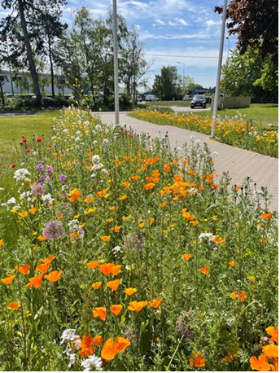

Coronavirus Resources
· Guidance for councils and LRFs during the coronavirus outbreak: https://www.gov.uk/guidance/coronavirus-covid-19-guidance-for-local-government
· Latest information on coronavirus: https://www.gov.uk/coronavirus
· Coronavirus communication materials:
https://coronavirusresources.phe.gov.uk/
· FAQ from the Cabinet Office: https://www.gov.uk/government/publications/coronavirus-outbreak-faqs-what-you-can-and-cant-do/coronavirus-outbreak-faqs-what-you-can-and-cant-do
· National lockdown: what you need to know:
https://www.gov.uk/guidance/local-restriction-tiers-what-you-need-to-know
· Coronavirus cases: https://coronavirus.data.gov.uk/
Previous MHCLG Coronavirus Bulletins:
https://bit.ly/3iC2Pnz

The Council’s online form for reporting health and safety concerns https://my.eastsuffolk.gov.uk/service/COVID_19_Health_and_Safety .
Enquiries can also be made to environment@eastsuffolk.gov.uk .

James Mallinder
Deben Ward
Environment Portfolio holder

