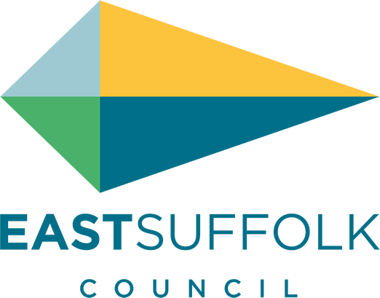

May 2021

Welcome to my monthly newsletter

Government roadmap out of restrictions
Overview
In the week up to April 28 there have been 192 new cases of COVID-19 in Suffolk. This is a rise on the numbers in the previous week.

The underlying rate of new weekly cases in Suffolk has risen and is now at 23.4 cases per 100,000 people. This rate is above the rates for the East of England region (21.1 / 100,000) and for England as a whole (24.8 / 100,000).

In total, up to April 16, 2021, which is the latest data from ONS, there have been 1,554 deaths in Suffolk where COVID-19 was recorded on the death certificate. There have been three COVID-19 related deaths in the seven days up to April 16.

The estimated ‘R’ value for the East of England is between 0.8 and 1.1. Both these values have increased compared to the previous week. The estimated ‘R’ value for England as a whole has also increased slightly this week (0.8– 1.0). Any R value greater than 1 means the epidemic may no longer be decreasing.

Weekly Cases and Rates
COVID-19 cases are identified by taking specimens from people which are then tested, either using a PCR test which is processed in a lab, or by using a rapid lateral flow device (LFD). Positive rapid lateral flow test results can be confirmed with PCR tests taken within 72 hours. If the PCR test results are negative, these are no longer reported as cases.

This policy was reintroduced in England on March 29, 2021. On April 9, 2021, a total of 116 cases with specimen dates after November 1. 2020, were removed from Suffolk’s cumulative total retrospectively due to meeting this criteria. In the week up to April 28, 2021 there were 192 new lab-confirmed cases of COVID-19 in Suffolk, an increase on the 151 cases of the previous week.

The most recent underlying weekly case rate in Suffolk was 23.4 cases per 100,000 people. This is a rise on the 18.5 case rate of the previous week. In the last week of reported data, up to April 28 there have been 7 cases in Babergh, 71 cases in East Suffolk, 46 cases in Ipswich, 19 cases in Mid Suffolk and 49 cases in West Suffolk.

Total Cases and Rates
As of April 28, 2021 there have been 30,200 total lab-confirmed cases of COVID-19 in Suffolk. In total there have been 3,966.6 cases of COVID-19 per 100,000 people.

Safe re-opening as restrictions lift

In total, since the launch of a plethora of new business grants in November 2020, ESC has made payments of more than £40m to businesses struggling due to enforced closure or severe restrictions on trading.

In terms of the Additional Restrictions Grant (ARG) this means we have now allocated over 79% of ESC’s total pot, well above the national average and on course to meet the government’s 30 June deadline to have allocated all ARG monies. Since the beginning of the pandemic the Council has allocated £106m of grants.

From 1 April ESC launched its Restart Grants Fund which provides grants to supporting the reopening of non-essential retail and hospitality/ accommodation providers, leisure, personal care and gyms. For non-essential retail grants are worth up to £6k and for hospitality etc are worth up to £18k.

These will be one -off payments and only for businesses who are on the ratings list. Businesses which are not rated will receive a similar payment from the ARG fund. ESC has been recently informed by government that this fund will be topped up by £1.74m dependent on the current allocation of £7.2m being fully distributed to businesses by 30 June.
The government has also recently announced the ‘Welcome Back Fund’ - £56m being made available to Councils to safely welcome back residents and visitors to high streets and coastal resorts. The funding can cover temporary measures such as signage, public realm improvements, promotional campaigns and support for events for up to 12 months or for as long as restrictions are in place.
ESC has been allocated £287k and once final guidance has been received from government the ED team will be working with Town Councils and Business Improvement Districts to develop plans for the effective implementation of this fund.
All the information relating to Covid business grants can be found on ESC’s Covid business support webpage COVID-19: business grant funding » East Suffolk Council.

Grants, funding and business matters

ESC has implementing longer-term business support measures to support local businesses through the reopening and recovery period. The ED team have developed draft business support proposals that are in line with our current economic growth priorities and build on the District’s economic strengths. The areas of support cover:
- Digital Transformation
- Town Centre Recovery
- Business Start-up
Cabinet recently approved these new business recovery support programmes and they will be fully developed and implemented in the spring/ summer

Testing
The Council encourages employees who are unable to work from home and are not experiencing COVID 19 symptoms to take regular Lateral Flow Tests (LFT) to detect asymptomatic COVID 19 cases. This Lateral Flow Testing Programme is open to all employees who are unable to work from home.

It is recognised that one in three cases of COVID-19 is thought to be asymptomatic and the introduction of a Lateral Flow Testing programme is designed to reduce transmission.

Meanwhile, Suffolk businesses are being encouraged to protect themselves by getting their staff tested for COVID-19 twice a week, as part of a new campaign launched by Suffolk County Council.

The Yes 2 Test campaign complements the Government’s roll-out of regular rapid testing for everyone, which began Friday, 9 April 2021.

Businesses across Suffolk are being asked to commit to whole-staff lateral flow testing, either through testing at their workplaces or encouraging staff to sign-up for home testing kits. Many businesses have already signed up to Yes 2 Test, such as Adnams, Notcutts and Berry Global, and this number is expected to grow as lockdown measures continue to ease and premises open again.

https://www.eastsuffolk.gov.uk/news/suffolk-businesses-say-yes-2-test-as-many-premises-prepare-to-open-on-monday/

Operational Services
Leisure centres reopened for limited, pre-booked activities on Monday 12th April. This included the newly refurbished Water Lane site in Lowestoft, with it’s new operator, Everyone Active. Early indications across all facilities is that take up is high, albeit the use of leisure centres is still relatively highly restricted until the further easing in May.

Additional facilities – coastal towns. ESC have installed additional toilets, bins and are funding additional street cleansing and bin collections in key coastal locations to manage the impact of high visitor numbers. We are working with communications to ensure that visitors are clear that we welcome responsible visitors, on behalf of our smaller coastal communities.

Misc

I am sorry to report there has been cases of fly tipping at Hollesley Village Hall
And vandalism of a number of pardon the weeds we are feeding the bees signs
This is very disappointing.

Please be vigilant and report any fly tipping

Also end of April it was my pleasure to open the new Butley Bus shelter which I helped to support through my enabling community budget - long may it keep people dry waiting for a bus or resting from a walk .

James Mallinder
Deben Ward
Environment Portfolio holder

