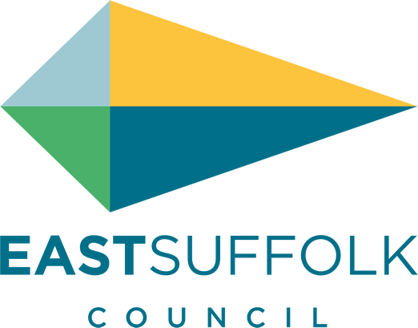

November 2020

Welcome to my monthly newsletter

New Chairman elected
East Suffolk Council elected its new Chairman at virtual Annual Meeting, which was held on 23 September.
Cllr Keith Robinson, who represents the Oulton Broad ward, will be Chairman for the remainder of the 2020/21 Municipal Year, taking on the post from Cllr Colin Hedgley.

New ‘Local Plan’ approved
East Suffolk Council have adopted the Suffolk Coastal Local Plan – an ambitious strategy to guide and manage new development for the former Suffolk Coastal area in a sustainable and plan-led way.
It proposes the delivery of at least 6,500 jobs and 9,756 new homes over the period to 2036, supported by the delivery of appropriate infrastructure whilst also setting out an approach to protect, maintain and enhance the high quality built, historic and natural environment, and mitigate and adapt to climate change.
To achieve this strategy, employment sites and residential sites have been identified in a variety of locations to realise the opportunities that exist across the Plan area, including the allocation of two new garden neighbourhoods at North Felixstowe and South Saxmundham.
The Plan will sit alongside the Waveney Local Plan which was adopted in March 2019, and the Local Plan for the Broads (prepared by the Broads Authority) which was adopted in May 2019, together providing up to date plans across the whole of East Suffolk.

New service for council tenants to be launched
East Suffolk Council’s housing tenants will soon be able to manage their tenancy more easily using a new online service, due to be launched later this year.
The new portal, called ‘myHome East Suffolk’ will be launched by the end of the year and will enable those living in council properties to manage payments, request repairs and make appointments quickly and easily.
More details about how to sign up for the new service will be released in the coming weeks and all tenants will be contacted directly regarding the new service.

East Suffolk residents encouraged to safely shop local
East Suffolk Council has launched a campaign to reassure the people of East Suffolk that there are robust safety measures in place in the town centres – and encourage them to support local businesses safely and regularly, to keep the local economy healthy.
Working with town councils, business associations and other local groups, the Council has compiled information on safety measures, how businesses have adapted, as well as guidance and advice. Supported by the Bridge Marketing, the Council has embarked on an informative campaign featuring videos, posters, information packs for businesses and a full social media campaign.
Those seeking further information should visit eastsuffolkmeansbusiness.co.uk where they can find a whole host of information, downloadable packs and where businesses can request campaign materials.

People encouraged to stay safe on our coast
A campaign was launched earlier this month to remind residents and visitors about the importance of staying safe on our coast.
Throughout the Covid-19 restrictions, and particularly since early summer, the Council’s Coastal Management Team has received almost daily reports from concerned landowners, businesses and the community about people climbing through eroding cliffs, climbing on top of sea defences and ignoring signs warning of potential dangers.
The campaign encourages people to visit the coast and enjoy all that there is to see and do but also aims to educate people to take care whilst they are there to ensure that their visit is enjoyable and safe. The campaign launched on social media and with posters and information in prominent local places.
Anyone who notice anything unusual or dangerous about cliffs or any coastal defences, should email coastalmanagement@eastsuffolk.gov.uk. In an emergency always call 999 and ask for the Coastguard.

Bawdsey in particular has suffered a large amount of cliff erosion so its important we stay safe if enjoying our beaches and coastal walks .

Major funding boost to help tackle homelessness
East Suffolk Council has been awarded £93,312 in funding as part of the Government’s Next Steps Accommodation Programme, to help vulnerable people housed during the pandemic stay in accommodation. Working closely with key partners across the district, the funding will enable the Council to continue to provide accommodation and support for vulnerable people placed under the Covid-19 provisions, including assisting with offers of accommodation in the private rented sector; offering employment and skills support through a personalised, one-to-one coaching service delivered by Access Community Trust; and providing additional emergency beds during the colder winter months.

Updated Grants page
We are pleased to update our grants page with two new grants
The community partnership small grants scheme designed for small improvements for the village hall and youth engagement , although you need to submit by 24 nov
AND
The bounce back fund which is useful for immediate funding to tackle covid – hand sanitizers , signage etc if you are opening the village hall
Although with the hall owned by the church some grants will be difficult to access
https://www.eastsuffolk.gov.uk/community/community-grants-and-funding/

New Support Service
Please be aware that the new Suffolk Advice and Support Service (SASS) is now up and running and supporting people. Guidance and help on rent / food vouchers for children / benefits etc
https://www.suffolk.gov.uk/coronavirus-covid-19/suffolk-advice-and-support-service/
and residents can talk to me in confidence any time .

James Mallinder
Deben Ward
Environment Portfolio holder

