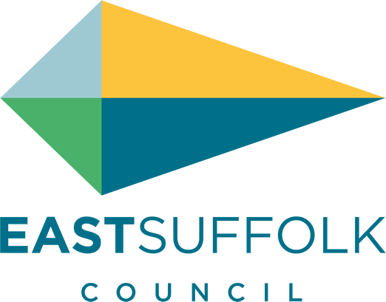

November 2021

Welcome to my monthly newsletter

Improving private rented homes in East Suffolk
We're working with Generation Rent UK to better support East Suffolk residents who privately rent their homes and help ensure that homes in the district are secure, safe and energy efficient.
Earlier this year, we asked private renters living in the Harbour & Normanston ward, Beccles & Worlingham ward and Aldeburgh & Leiston wards, to share their experiences in a survey.
Findings from the survey revealed that private renters in these three wards are most concerned about:

• losing their tenancy
• being unable to move into homeownership
• rent increases
• almost 50% of those surveyed are concerned to some degree about being asked to leave their home by their landlord or letting agent this year.

As part of this work, we will be running focus group discussions later this year. Anyone who rents privately in East Suffolk can get involved in these, regardless of which ward they live in. Eligible participants will receive a £10 shopping voucher.
People can sign up now at https://my.eastsuffolk.gov.uk/service/Private_renter_session_registration

Support available to help businesses recover
Funding and support is available for businesses in East Suffolk which have been, and continue to be, severely affected by Covid-19 restrictions.

Delivered in partnership with the New Anglia Local Enterprise, the new ‘Plan for the Future’ scheme provides support to local businesses which are looking to bring forward investment projects that will have a significant impact on their business. Eligible businesses will be able to apply for grants of between £5,000 and £25,000 to help support their projects.
Businesses wishing to apply for support should first contact the New Anglia Growth Hub on 0300 333 6536 or email growthhub@newangliagrowthhub.co.uk

Expert and impartial Business Growth Advisers will work with businesses to develop an action plan and complete the application.
See more information at www.eastsuffolk.gov.uk/news/support-available-to-help-businesses-recover/

Key infrastructure projects to benefit from £6.3m funding
Over £6 million in contributions from new housing developments has been allocated to support the expansion of schools, leisure and health facilities in East Suffolk.
Earlier this month, cabinet agreed to award a total of £6,308,245 in Community Infrastructure Levy (CIL) funding to support seven major projects which are identified within the Local Plan as being key to planned growth within the local area.

CIL is a fee which we can charge developers when new housing is built in the district. CIL can then be put towards improvements to local infrastructure, such as play areas, schools and GP surgeries. We hold a list of key projects which are included in the Local Plan and these projects are then put forward for the latest round of CIL funding.

See more details about the projects at www.eastsuffolk.gov.uk/news/key-infrastructure-projects-to-benefit-from-6-3m-funding/

Helping young people take the next step
We’re continuing to support young people with further funding agreed by cabinet for the East Suffolk Youth Employment Service (YES), which is helping young people, aged between 16 and 24 years old, to find employment and training opportunities.

Delivered by Inspire Suffolk, young people can visit the dedicated YES. Suffolk website at www.yessuffolk.co.uk to view current job opportunities, find training programmes and other support information and advice. Referrals can also be made by community groups. Young people will be allocated an employment coach to support them into appropriate work, education or training. Wellbeing services are also available, provided by Inspire Suffolk.

Community Partnership Grant
The Melton, Woodbridge and Deben Peninsula Community Partnership has launched a third round of its Small Grant Scheme which offers funding to voluntary and community groups within the Partnership.
The Youth Engagement Grant Scheme offers funding to projects aimed at improving the opportunities and services available to young people. This could include providing new activities centred around life skills, fun or leisure or improving or creating new outdoor spaces or play equipment.
The Village Hubs Grant Scheme offers funding to projects aimed at creating or improving village hubs to the benefit of the wider community. This could include assistance in making premises in the area fit for use as a community hub or supporting mobile services in bringing provisions to a village.

James Mallinder
Deben Ward
Environment Portfolio holder

